EXPERIMENT 7
Name: Abinash G
Roll no: 240701007
Design an application layout using different colors, text styles, and visual elements. Share the design with users through a Google Form or any other feedback collection method to gather their responses. Based on the feedback received, refine and improve the design accordingly.
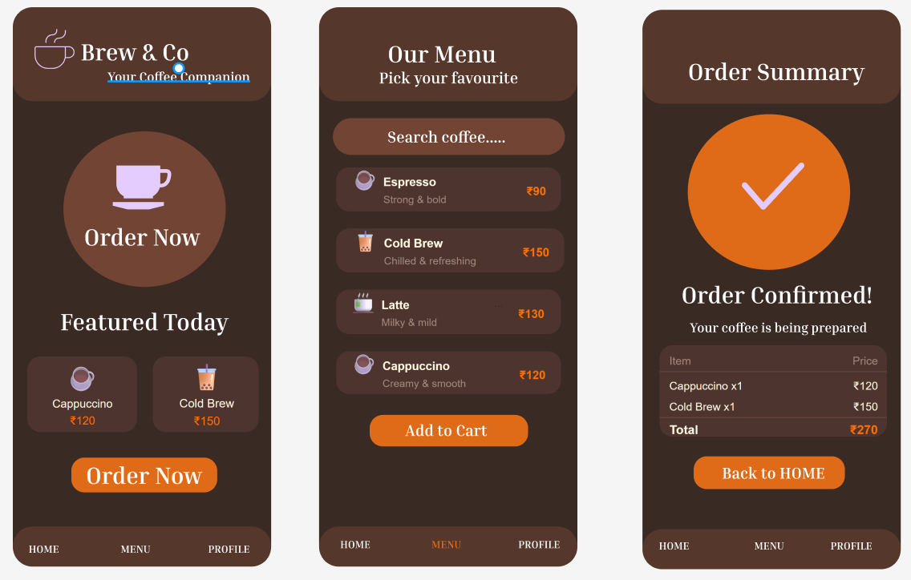
1. Objective
To design a mobile application interface for a Coffee Shop using appropriate colors, typography, and visual elements, and to collect user feedback using a Google Form to improve the design.
2. Application Overview
The designed application is a Coffee Shop Ordering System that allows users to:
- Browse different types of coffee
- View coffee details (price, description)
- Add items to cart
- Place orders easily
- Receive order confirmation
The goal of the app is to provide a simple and smooth coffee ordering experience for users.
3. Design Process
a. Color Selection
- Dark Brown is used as the primary theme to represent coffee and warmth
- Light Brown / Beige is used for contrast and readability
- Orange is used for buttons to highlight actions
- White is used for text visibility
b. Typography
- Bold fonts are used for headings (e.g., Brew & Co.)
- Medium-sized fonts for coffee names
- Smaller fonts for descriptions and additional details
c. Layout Design
The application consists of three main screens:
1. Home / Menu Page
- Displays coffee items such as:
  - Espresso
  - Cappuccino
  - Cold Brew
- Each item includes:
  - Name
  - Description
  - Price
  - Add (+) button
2. Cart / Order Page
- Shows selected coffee items
- Displays total price
- Includes “Order Now” button
3. Confirmation Page
- Displays success message: “Order Confirmed!”
- Shows estimated delivery time
- Includes confirmation icon (✔)
- Option to return to home
4. Tools Used
- Figma (for UI design)
- Google Forms (for feedback collection)
5. Feedback Collection Method
A Google Form was created and shared with users to gather their opinions on the application design.
https://docs.google.com/forms/d/e/1FAIpQLSeir8q4Tp6EizDgggWGk2F53xpIL4OPzasmA51YWkRe0wZyoQ/viewform?usp=publish-editor

6. Sample Questions in Feedback Form
- How easy is the app to use?
- Is the design visually appealing?
- Are the colors suitable for a coffee theme?
- Is the layout easy to understand?
- Suggestions for improvement
7. Feedback Analysis
Based on user responses:
- Most users found the app easy to use
- Some suggested improving text visibility
- A few users recommended better spacing
- Some suggested making buttons more attractive
8. Improvements Made
- Increased contrast between text and background
- Improved spacing between elements
- Enhanced button design
- Made layout more clean and organized
9. Result
The refined design became:
- More user-friendly
- Visually appealing
- Easy to navigate
- Better user experience
10. Conclusion
This experiment helped in understanding:
- Importance of UI design
- Role of color and typography
- User feedback in improving design
- Creating user-friendly applications

